Pong Planning and Analysis:

Statement of Problem:
Code the game Pong in the C# console.

Analysis (Meta-Data):
- Console screen should be cleared at the start of the program
- What input devices will we make use of? User input from keyboard
- How will output be displayed? Text in the console window and maybe scores saved to a notepad file .txt
- Console window range (around 80, 25)
- Game should contain two bats one ball
- Scores should be displayed and incremented when the ball hits the side
- The paddle should not move off the screen and the program should not crash if the paddle does hit the edge
- The ball should bounce when it hits the edge of the console screen
- The bats should move up and down the y axis
- The ball should bounce (change direction) when it hits either of the bats
- If the ball hits the console screen without hitting a bat the player whose side it hit will lose 1 point
- The game will end once a player has won 5 points
- The ball and bats should be refreshed so it gives the illusion of movement
- The program should exit once the escape key is pressed
- The there should two keys assigned for vertical movement for each bat
- The game should include some colour

Design - With the information collected we can design an algorithm:
Problem: The program should exit when escape key is pressed.
Algorithm: Create a Boolean variable escape which is default set to false, put the entire program into a loop that only loops while escape is still false. Make a case statement that when the escape key is pressed Boolean value escape is changed to true.

Problem: The ball and bats should be refreshed so it gives the illusion of movement.
Algorithm: A blank string should be written in the last position the ball was on (x & y axis), for the bats a ‘for loop’ could be created to create a blank string to refresh the column in which a new bat will be redrawn onto.

Problem: The program should halt all bat and ball activity and display Game Over would you like to try again when either player gets 5 points.
Algorithm:
Create some variables
- boolean (enterButton) by default set to false, when enter key is pressed this is triggered to true
- string (playerWon) this is a empty string that gets injected in the method below
Create a method called gameOver which contains:
- if player one has a greater score than player two, (playerWon) becomes the string Player One and vice versa.
- Display a console string in the middle of the screen which says GAME OVER (playerWon) Won! and press enter to play again or escape to exit.
- if the enter button is pressed the boolean variable of (enterButton) becomes true

Main Method:
- When either players scores become 5 the method gameOver gets called
- if the boolean value enterButton becomes true the gameOver method is ended and the main method is called this resets the program

Testing and bug testing
Problem: Encountered a problem with the paddles as it went past the top of the console window y axis -1, the program crashed due to trying to reach 'out of the range' of the console window buffer area.
Where is the mistake?: There is nothing stopping the paddles from going beyond the range of the console buffer
Solution: I made if statements in the case statements which controlled the key inputs for the up and down movement of the paddles. If the either paddle equalled the top of the console window then the up direction key would not perform (thus making it impossible to make the bat go higher than the edge), however the user would still be able to go down. If the either paddle reached the bottom of the screen it would be the similar effect but reversed.

Successful Tests:
Ball Bounces off roof and floor and paddles
Ball Starts from centre when it hits the sides without touching a paddle
Enter restarts the program when a player has won the round (5 points per round)
Escape exits the program promptly
Paddles do not crash the program neither do they go past the border
Console beep sound occurs when a paddles hits the ball

Version Control:
1.0: Drew bats and bat on screen, colours implemented, ball bounces off sides and around the screen.
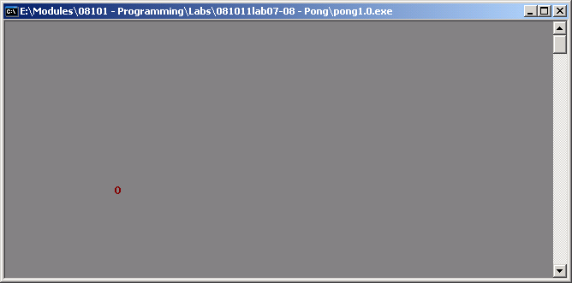
1.1: Bats move within the border range, border added.
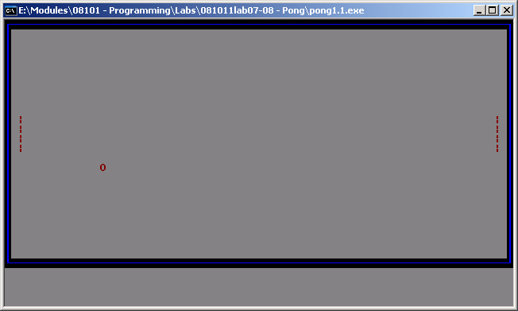
1.2: Sped up the system processes, added a console title, placed scores underneath border but not yet working.
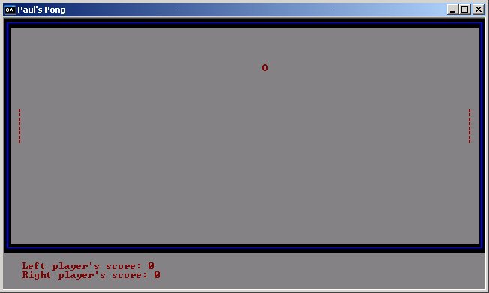
1.3: Bats now incorporate collision detection, scores now increment, ball will reset to the middle when hits the side without hitting a paddle.
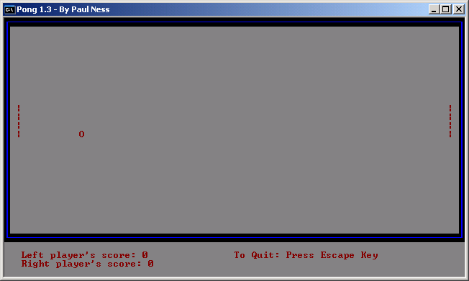
1.4: Now a Game Over screen has been added when a player gets 5 points you can restart the game by pressing enter, this will also reset the scores.
